SIMATS ENGINEERING
ASSESSMENT TOOL 1 : Concept Mapping

COURSE NAME: Cloud Computing and COURSE CODE: CSA15
Big Data Analytics

COURSE OUTCOME COVERED
CO1: Apply cloud computing technologies including hardware-software evolution, virtualization, web services, and service models to develop cloud-based solutions. (BL2)

Dave's Taxonomy: Imitation (Level 1) Total Marks: 50
Question Count: 4

Code of Conduct
I T.Dinesh(192511343) (Name / Reg No) certify that this submission is my original work and that I have adhered to the guidelines specified for this assessment.
I understand that any violation of academic integrity rules will result in disciplinary action.
Signature of the student: T.Dinesh

Assessment Tasks Concept Mapping Tasks
Create concept maps for the following tasks. Each map must show key nodes, link labels, and a logical hierarchy.
- Concept Map 3: Service Models. Map IaaS, PaaS, SaaS, and XaaS with provider responsibilities and user responsibilities.
- Concept Map 4: Virtualization and Web Services as Enablers of Cloud. Show how these two concepts support cloud deployment and scalability.
Expected concept nodes:
- Elasticity, scalability, resource pooling, on-demand access, measured service
- Virtual machine, hypervisor, abstraction, API, SOAP, REST, provider, consumer
- Infrastructure layer, platform layer, application layer, shared responsibility

Concept Map 3: Service Models. Map IaaS, PaaS, SaaS, and XaaS with provider responsibilities and user responsibilities.

Task 1: Concept Map
Create a concept map in draw.io, Lucidchart, Miro, Figma, or any suitable diagramming tool. The map must connect cloud ecosystem, cloud actors, service models, deployment models, virtualization, web services, REST/SOAP APIs, scalability, elasticity, and the student's Project.
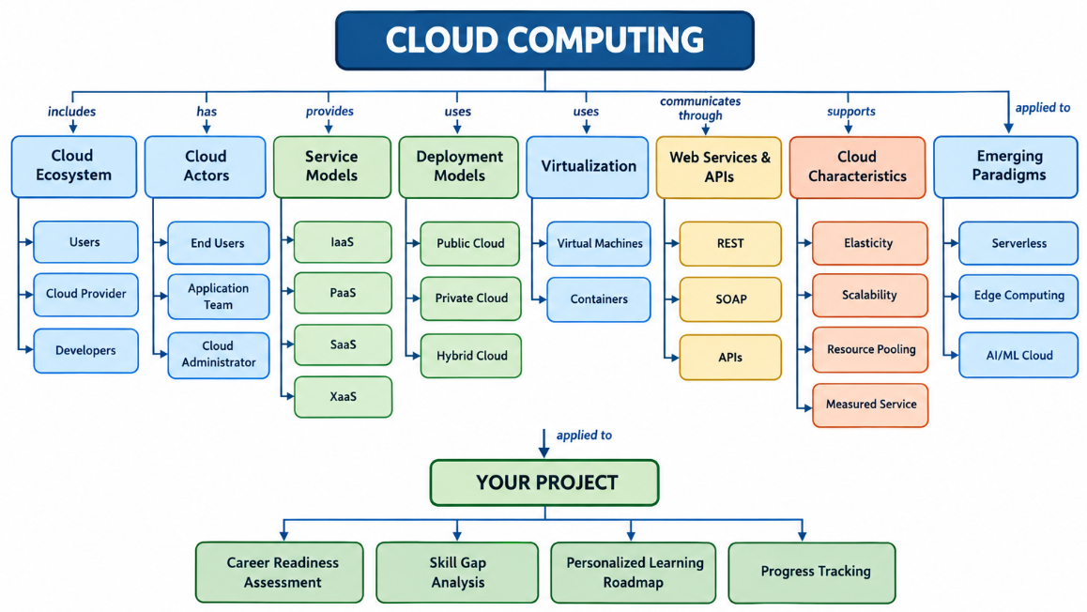

Task 2A: Service Model Responsibility Matrix
Prepare a technical matrix that compares SaaS, PaaS, IaaS, FaaS/serverless, database-as-a-service, storage-as-a-service, identity-as-a-service, and monitoring/logging services. For each selected service category, explain what is managed by the cloud provider, what is managed by the student application team, and why that split fits the Project.
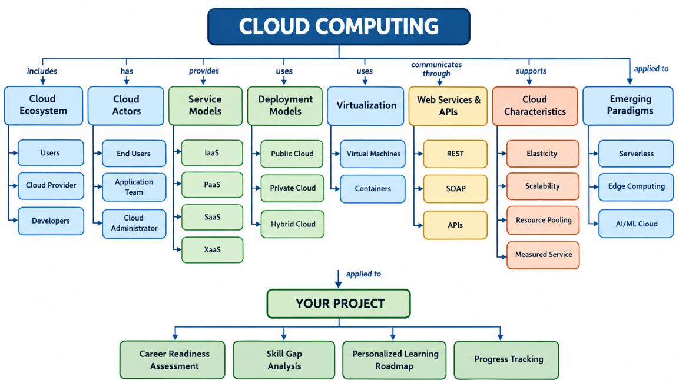

Task 2B: Cloud Service Decision Matrix
Map Project modules to cloud services. Include authentication, frontend hosting, backend/API layer, database, object storage, analytics/logging, notification, AI/Python module, security, CI/CD, backup, and monitoring. Students should justify the most relevant service choices instead of forcing every possible cloud service into the design.
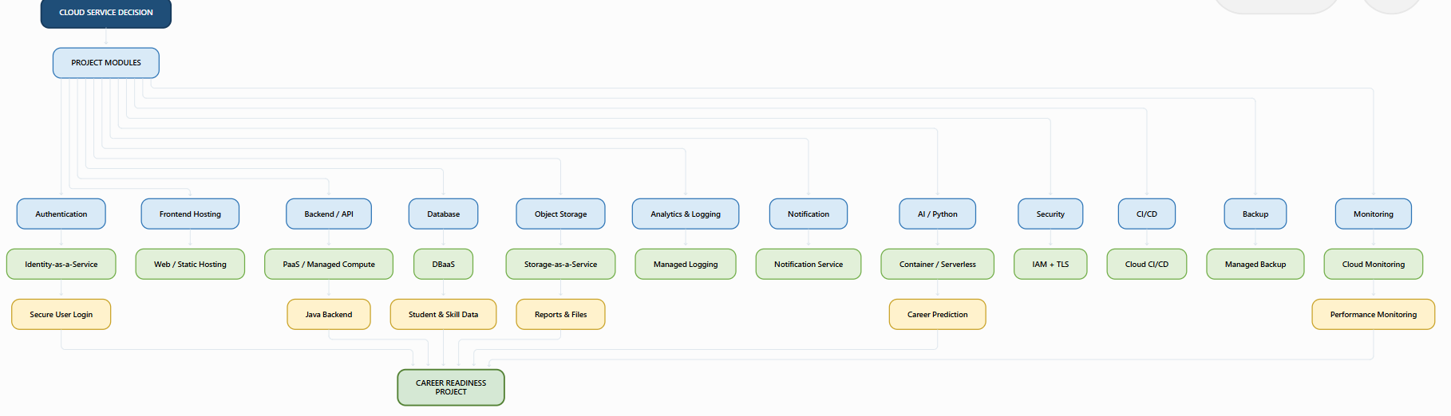

Task 3: API Flow, Elasticity, and Scalability Design
Draw a professional cloud-flow diagram for the Project modules. The diagram must show user app or web app, API gateway/backend service, authentication, compute layer, database, object storage, analytics/logging, monitoring, security boundaries, and scaling points. Students may replicate the given visual pattern, but all components and labels must be customized to their own architecture.
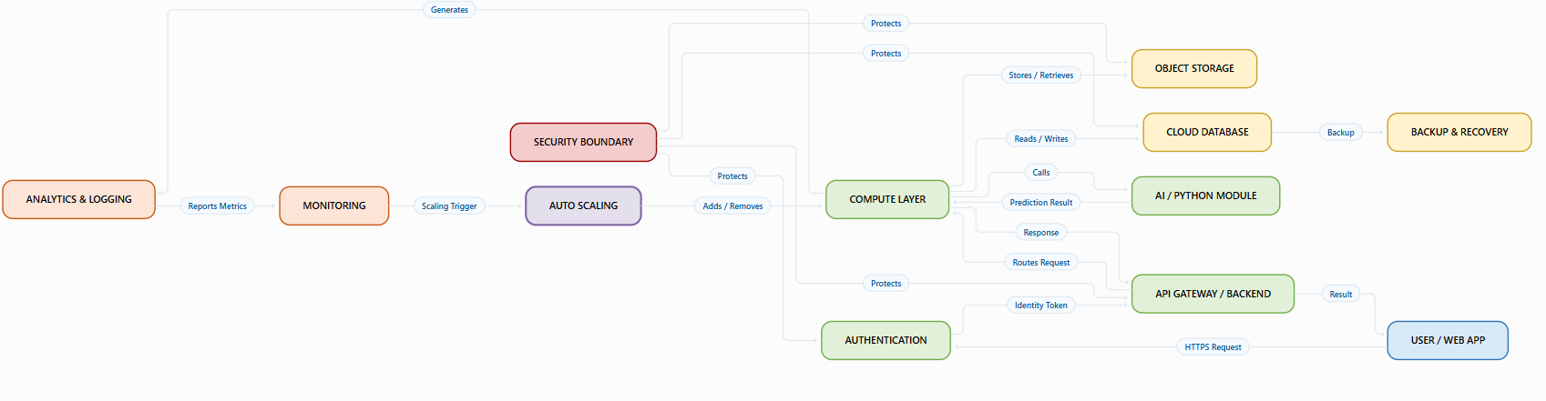

Task 4: Technical Justification
Write a concise justification explaining how the diagram and matrices prove CO1. The justification must discuss service model selection, API role, elasticity, scalability, virtualization or managed compute choice, and cloud responsibility boundaries.
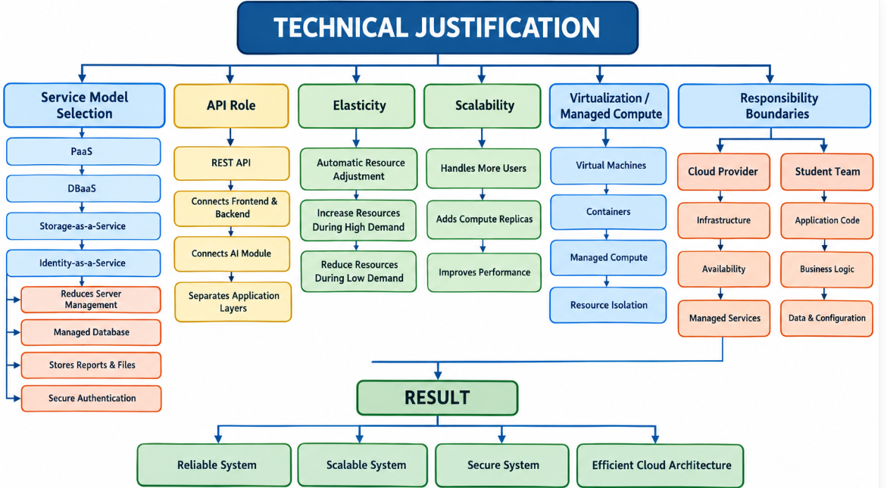

Concept Map 4: Virtualization and Web Services as Enablers of Cloud. Show how these two concepts support cloud deployment and scalability.

Task 1: Concept Map
Create a concept map in draw.io, Lucidchart, Miro, Figma, or any suitable diagramming tool. The map must connect cloud ecosystem, cloud actors, service models, deployment models, virtualization, web services, REST/SOAP APIs, scalability, elasticity, and the student's Project.
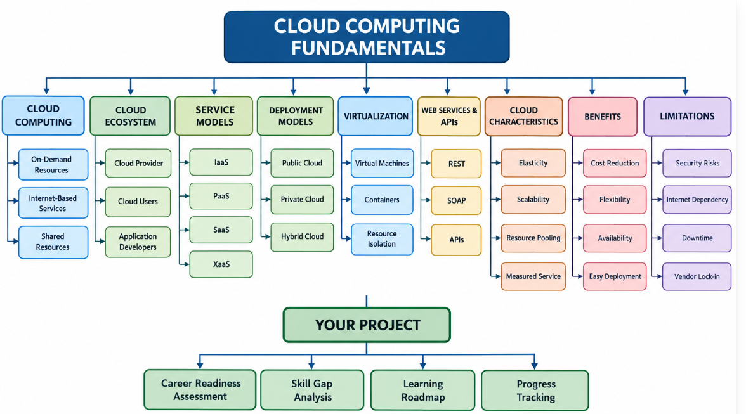

Task 2A: Service Model Responsibility Matrix
Prepare a technical matrix that compares SaaS, PaaS, IaaS, FaaS/serverless, database-as-a-service, storage-as-a-service, identity-as-a-service, and monitoring/logging services. For each selected service category, explain what is managed by the cloud provider, what is managed by the student application team, and why that split fits the Project.
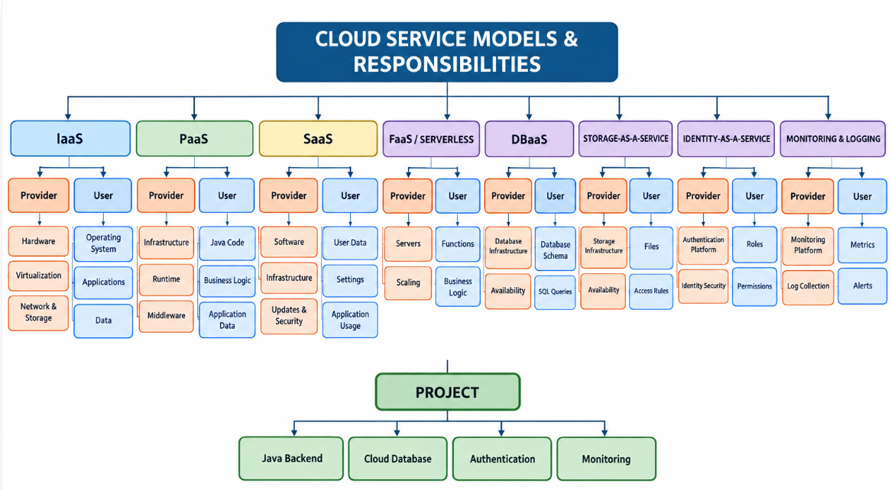

Task 2B: Cloud Service Decision Matrix
Map Project modules to cloud services. Include authentication, frontend hosting, backend/API layer, database, object storage, analytics/logging, notification, AI/Python module, security, CI/CD, backup, and monitoring. Students should justify the most relevant service choices instead of forcing every possible cloud service into the design.
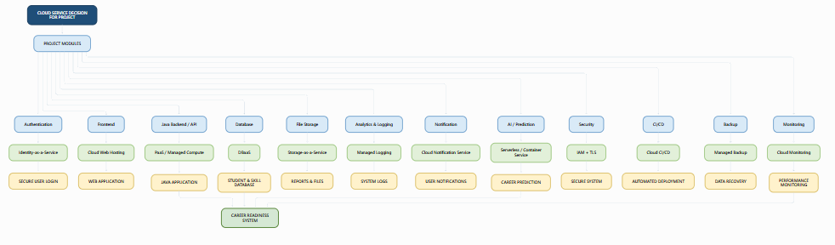

Task 3: API Flow, Elasticity, and Scalability Design
Draw a professional cloud-flow diagram for the Project modules. The diagram must show user app or web app, API gateway/backend service, authentication, compute layer, database, object storage, analytics/logging, monitoring, security boundaries, and scaling points. Students may replicate the given visual pattern, but all components and labels must be customized to their own architecture.
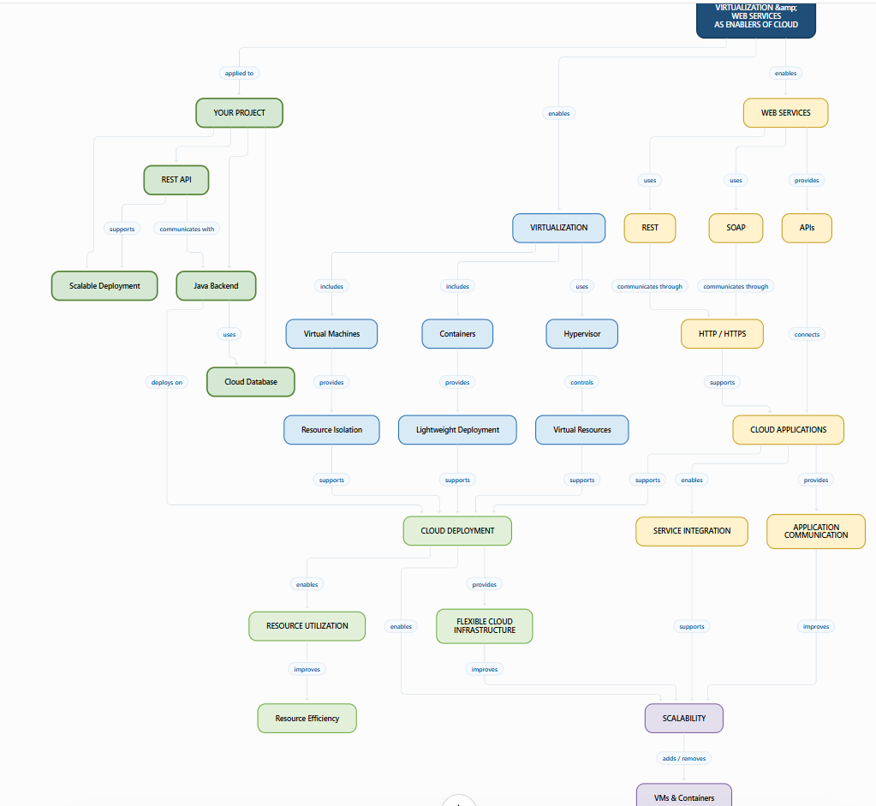

Task 4: Technical Justification
Write a concise justification explaining how the diagram and matrices prove CO1. The justification must discuss service model selection, API role, elasticity, scalability, virtualization or managed compute choice, and cloud responsibility boundaries.

